TASK | Aerosol application of contact cleaner and protector.
LOCATION OF USE | Workshop and on Client sites |  | Assessment  No |  | 015
PRODUCT NAME | De Solv It Contact Cleaner and Protector Aerosol |  |  |  | 015
DESCRIPTION OF SUBSTANCE | Corrosion inhibitor |  |  |  | 015
MANUFACTURER | Mykal Industries Ltd |  |  |  | 015
MANUFACTURERS CONTACT | Tanhouse Lane  Widnes, Cheshire  WA8 0RR  Tel. 0151 422 1180  e-mail, enquiries@mykal.co.uk |  |  |  | 015
ASSESSOR | Martin Monaghan CMIOSH |  | Date |  | 23 07 24
TITLE | Health and Safety Consultant |  | Review by |  | 23 07 26
Personnel Performing Task  (Please list below)  Technicians/ Fitters/ Workshop Operatives |  | Time Spent  (Minutes/day)  As and when required, amounting to a few minutes per day | Training Given 
 |  |  | Yes

MSDS Revision Date | Hazard Statement
17.07.2013 – version 4 | R12 Extremely flammable.  R65 Harmful: may cause lung damage if swallowed.  R66 Repeated exposure may cause skin dryness or cracking.

Assessment to be conducted in Association with Hazard Data Sheets, a full current copy of which must be attached to this assessment.

Please denote the hazardous properties of the substances used in the task with a

NEW INTERNATIONAL GLOBALLY HARMONISED HAZARD SYMBOLS
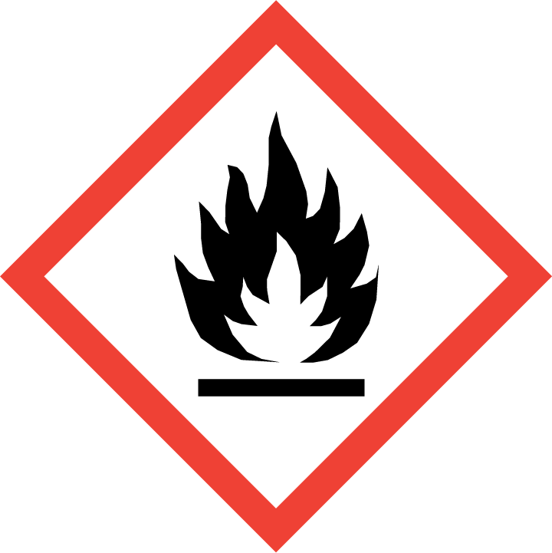 | 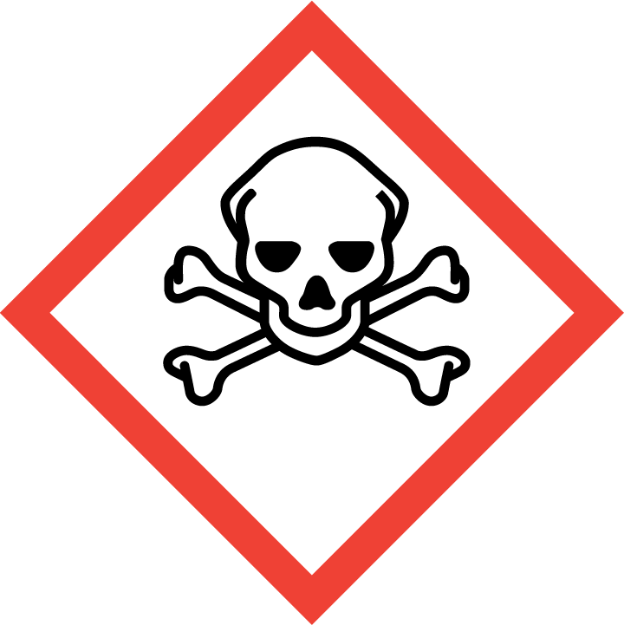 | 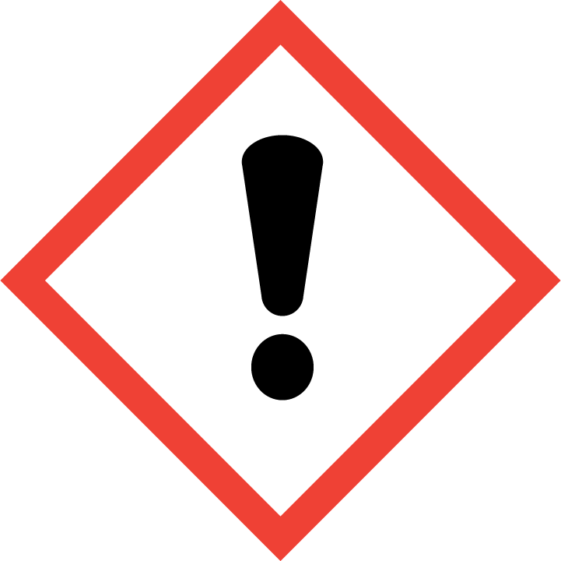 | 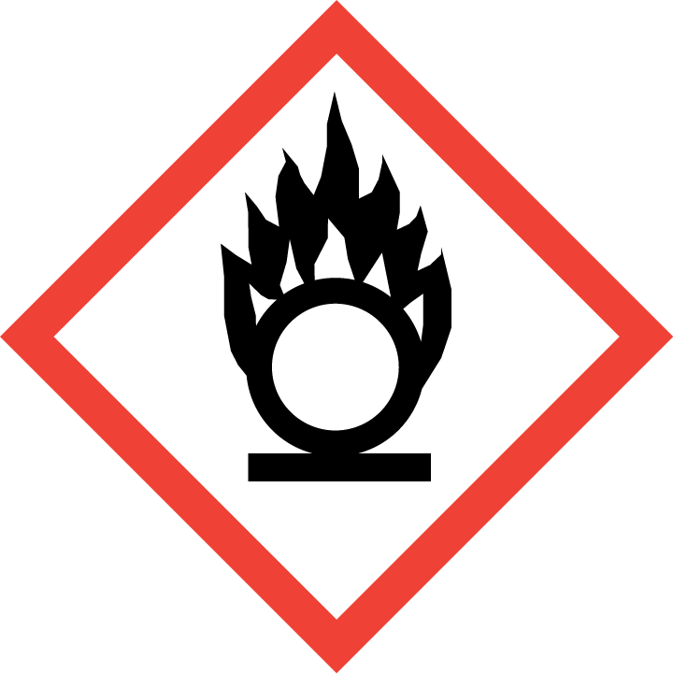 | 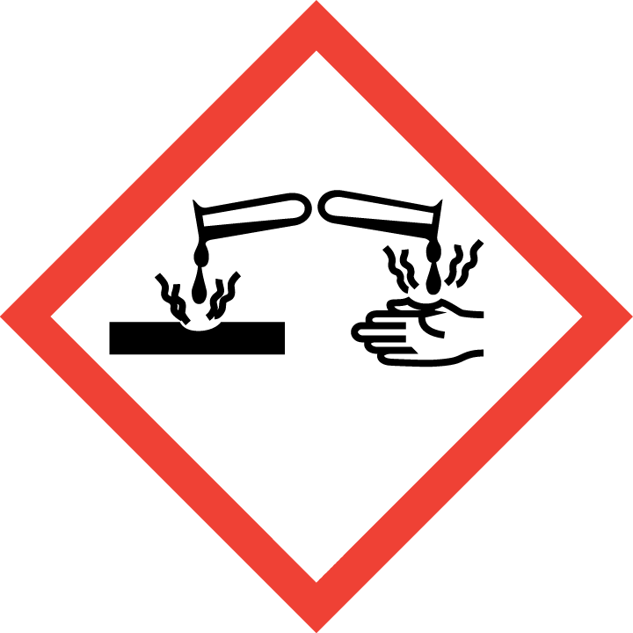 | 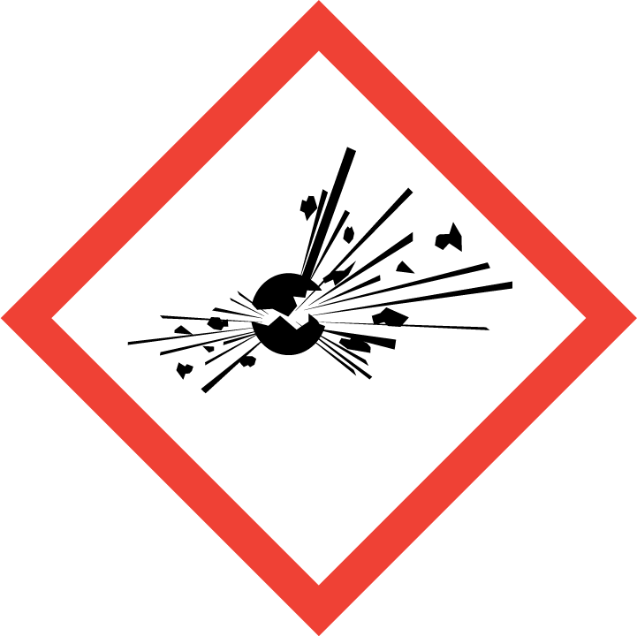 | 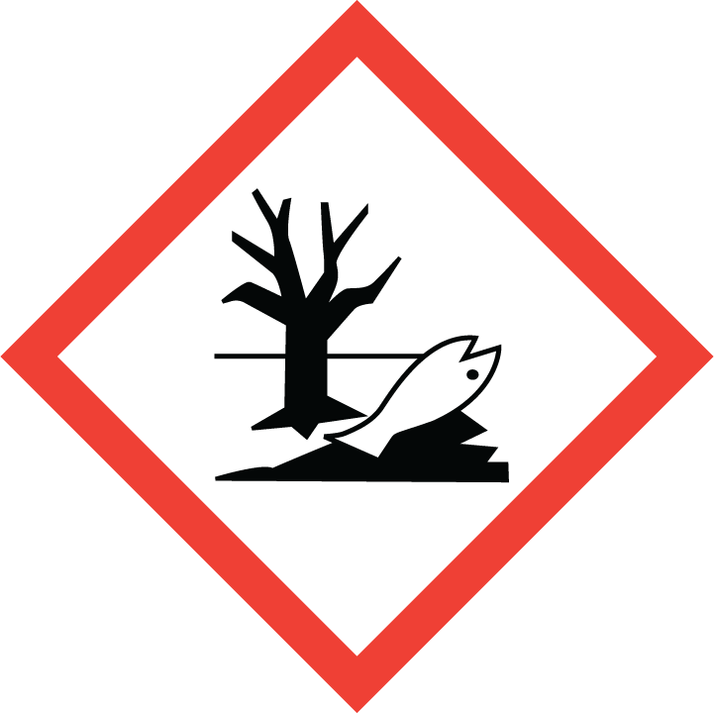 | 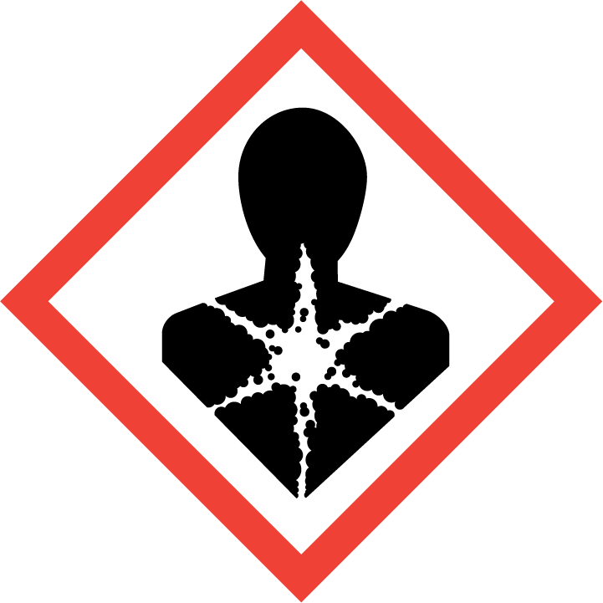
Flammable | Toxic | Harmful | Oxidising | Corrosive | Explosive | Harmful to the environment | Health Hazards i.e. respiratory sensitisation or carcinogenicity

SMOKING, EATING AND DRINKING ARE PROHIBITED IN THE WORK AREAS.
Information, Instruction and Training must be provided to all users. Young Persons, New or Expectant Mothers and other vulnerable groups must not use or be exposed to this product.

WORKPLACE EXPOSURE LIMITS (WEL’s)
No WEL applicable for product.

IMPORTANT!
Refer to Workplace Exposure Levels information provided in the Manufacturers Safety Data and revise control measures if exposure levels likely to be reached.

ROUTE OF EXPOSURE
Skin |  | Eyes |  | Inhalation
Ingestion |  | Cuts/abrasions |  | Systemic

PERSONS AT RISK
User of product |  | Co workers |  | Members of the public

ROUTE OF EXPOSURE |   FIRST AID MEASURES
Eyes | Rinse opened eye for several minutes under running water.
Skin | Immediately wash with water and soap and rinse thoroughly. If skin irritation continues, consult a Doctor.
Inhalation | Supply fresh air, consult a Doctor in case of complications.
Ingestion | Seek immediate medical advice.
In all cases of doubt, or if symptoms persist seek medical attention. Never give anything by mouth to an unconscious person. If unconscious, place in recovery position and seek medical advice.

PERSONAL PROTECTIVE EQUIPMENT
 |  | 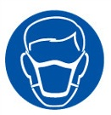 |  | 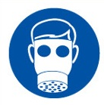 |  | 
YES | YES | YES/NO |  | YES/NO | YES | YES/NO
Wear approved chemical safety goggles where eye exposure is reasonably probable. | Wear appropriate clothing to prevent repeated or prolonged skin contact. |  |  |  | For prolonged or repeated skin contact use suitable protective gloves. Nitrile gloves are recommended.

HANDLING | STORAGE | TRANSPORT | DISPOSAL
Risk of vapour concentration on the floor and in low-lying areas. Static electricity and formation of sparks must be prevented. Avoid eating,  drinking and smoking when using the product. | Keep away from heat, sparks and open flame. Pressurised container: Must not be exposed to temperatures above 50°C. Store in a cool  and well-ventilated place. Do not pierce or burn | Transport minimum amounts upright in the Engineers vans secured to reduce movement in transit. | Dispose of waste and residues in accordance with local authority requirements.

REQUIRED CONTROL MEASURES
- Users to avoid contact with skin and eyes, and inhalation of vapours/ spray or mist arising from the application of this preparation – Use PPE.
- Wash contaminated clothing before reuse. Wash hands after contact. Use appropriate hand lotion to prevent defatting and cracking of skin. Promptly remove non-impervious clothing that becomes wet or contaminated. When using, do not eat, drink or smoke.
- Ensure adequate welfare and washing facilities available and provide users with barrier and restorative creams. Take good hygiene measures.
- Ensure operatives are made aware of and understand the purpose of this assessment and MSDS, plus any health implications of using the product.
- Ensure COSHH assessments with accompanying MSDS are made available for all employees and users and for inspection and emergency purpose.
- Carry out personal exposure monitoring.
- Wash promptly if skin becomes contaminated. Wash hands at the end of each work shift and before eating, smoking and using the toilet.

FIRE PRECAUTIONS
EXTINGUISHING MEDIA – C02, sand, dry powder – do not use water.

ACCIDENTAL RELEASE/SPILLAGE PROCEDURES
PERSONAL PRECAUTIONS
Use protective gloves, goggles and suitable protective clothing. Take precautionary measures against static discharges. Avoid inhalation of vapours and contact with skin and eyes.
ENVIRONMENTAL PRECAUTIONS
Do not allow to enter sewers/surface or ground water.

MONITORING REQUIREMENTS AND HEALTH SURVEILLANCE
Health surveillance is not in place for workers exposed to this product.

